Assigment 4

I imported three libraries for this assigment:
- numpy (imported as np): Used for array handling and mathematical operations such as matrix multiplication and element-wise operations.
- matplotlib.pyplot (imported as plt): Used for creating visualizations, such as scatter plots for data and line plots for decision boundaries.
- scipy.optimize (imported as minimize): Used for optimizing the logistic regression cost function to find the best model parameters through the minimize function.
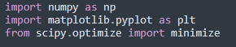
In the first step I loaded the dataset using numpy’s loadtxt() function. The dataset, stored in the file Assignment3data2.txt, contains test results for microchips, with the first two columns representing the test results and the last column indicating whether the microchip passed (1) or was rejected (0).
- X: contains the test results (features)
- Y: contains the target values (0 or 1, indicating rejection or passing)
- M: is the total number of training examples
The data is visualized using a scatter plot. The points are color-coded based on whether the microchip passed (blue) or failed (red). The x-axis represents the result of Test 1, and the y-axis represents the result of Test 2. We can see that the points are scattered across the graph, with no clear linear separation between the passed and rejected microchips, suggesting the need for more advanced techniques (like polynomial feature mapping or regularization) to effectively classify the microchips based on these test results.
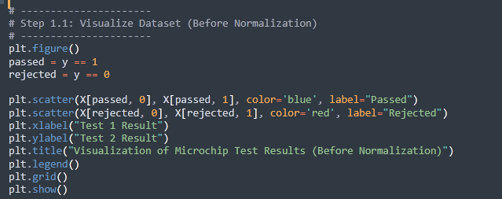
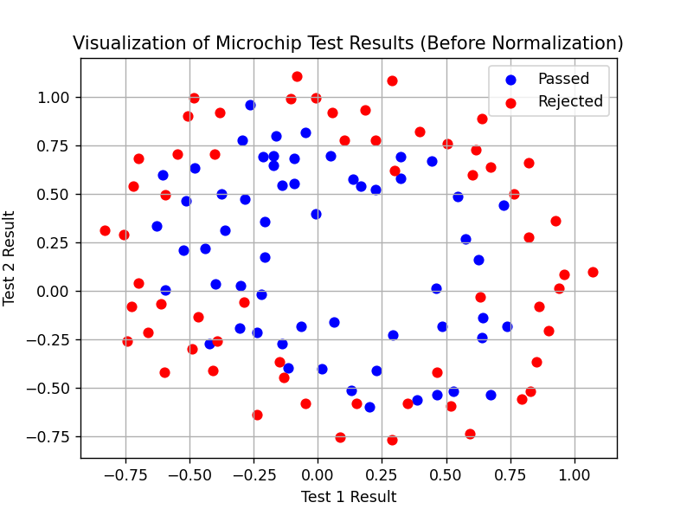
Next, the normalize_features() function normalizes the input features so that each feature has a mean of 0 and a standard deviation of 1.
- Input: X – The feature matrix (m x n) where m is the number of training examples, and n is the number of features (test results).
- Output: X_norm – The normalized feature matrix (m x n), mu – The mean of each feature, sigma – The standard deviation of each feature.

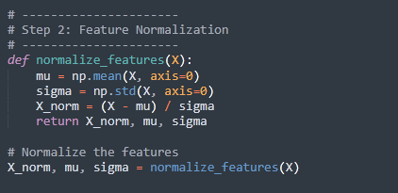
Using map_feature function the two input features into higher-dimensional polynomial features. This allows the model to handle non-linear decision boundaries by transforming the original features into combinations of polynomial terms.
Input:
- X1, X2: The two input features (test results of the microchips)
- degree: The degree of the polynomial (default is 6)
Output: a matrix of polynomial features, where each feature is a combination of X1 and X2 raised to different powers
The code constructs polynomial features for logistic regression by systematically creating combinations of two input features, X1 and X2. It starts with out = [np.ones(X1.shape[0])], which creates a column of ones to serve as the bias term (intercept). This bias term ensures the model can handle an offset.
The outer loop, for i in range(1, degree + 1), iterates through the degrees of the polynomial features, starting from 1 up to the specified degree. For each degree i, the inner loop, for j in range(i + 1), generates all possible combinations of X1 and X2 where the powers of X1​ and X2​ add up to iii.
Within the inner loop, the combination is computed with out.append((X1 ** (i - j)) * (X2 ** j)), where X1 is raised to the power (i−j), X2 is raised to j, and their product is added to the feature list.

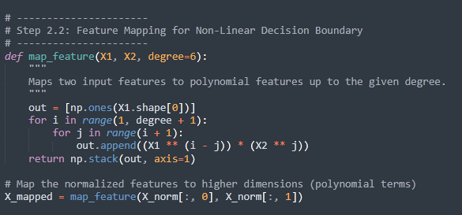
The sigmoid function maps any real number into the range [0, 1], making it suitable for binary classification tasks like this one.
- Input: z – The input, which can be a scalar or vector
- Output: The sigmoid of z, which is the probability of a given input belonging to the positive class
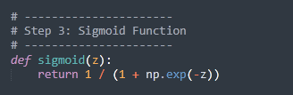
Logistic regression aims to minimize the cost function to find the optimal model parameters. The cost function for logistic regression with regularization is defined as:
J(w,b)=−1m∑i=1m[yilog⁡(hw(xi))+(1−yi)log⁡(1−hw(xi))]+λ2m∑j=1nwj2J(w, b) = - \frac{1}{m} \sum_{i=1}^{m} \left[ y_i \log(h_w(x_i)) + (1 - y_i) \log(1 - h_w(x_i)) \right] + \frac{\lambda}{2m} \sum_{j=1}^{n} w_j^2J(w,b)=−m1​i=1∑m​[yi​log(hw​(xi​))+(1−yi​)log(1−hw​(xi​))]+2mλ​j=1∑n​wj2​
The function compute_cost_with_regularization(theta, X, y, reg_param) as:
- Input:
  - theta: The model parameters (weights).
  - X: The feature matrix (m x n).
  - y: The target vector (m x 1).
  - reg_param: The regularization parameter\lambda.
- Output: The regularized cost, which includes a penalty term to avoid overfitting.
This function calculates the logistic regression cost with an additional regularization term to help avoid overfitting.
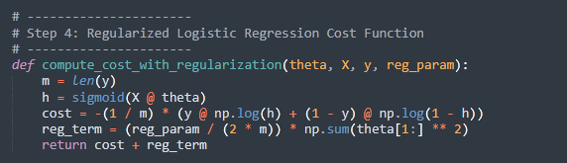

Gradient Function with Regularization:
The gradient of the cost function is used to update the model parameters during training. The gradient with regularization is calculated with compute_gradient_with_regularization(theta, X, y, reg_param) function:
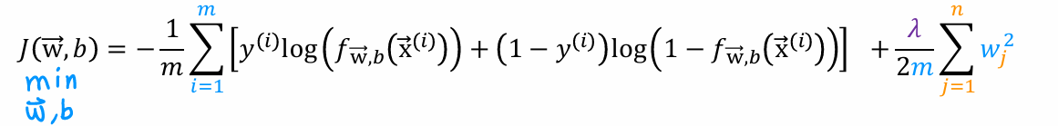
- Input: Same as compute_cost_with_regularization()
- Output: The gradient vector for the model parameters.
This function computes the gradient, which is used to update the parameters in the gradient descent optimization process.

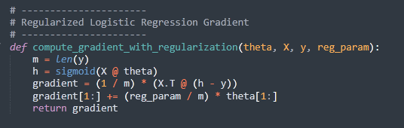
In the fifth step, the model parameters are optimized by minimizing the cost function. This function applies gradient descent to find the optimal weights that minimize the cost.
- Input:
  - fun: The cost function (compute_cost_with_regularization).
  - x0: The initial guess for the parameters (usually zeros).
  - args: The input data (X, y, and reg_param).
  - jac: The gradient function (compute_gradient_with_regularization).
  - options: Optimization settings (e.g., number of iterations).
- Output: The optimized model parameters (optimal_theta).

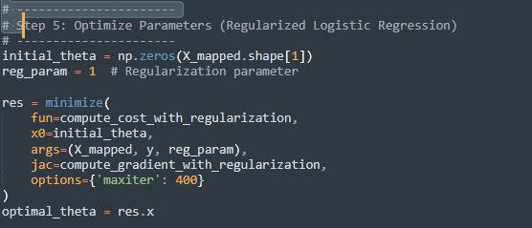
The decision boundary is plotted to visualize how well the logistic regression model separates the passed and failed microchips. It shows the region of the feature space where the model predicts a pass.
- Input:
  - theta: The optimized weights
  - X: The feature matrix
  - y: The target vector
  - degree: The degree of the polynomial features
- Output: A plot showing the decision boundary
The decision boundary is shown as a green curve that separates the two classes (microchips that passed the test and microchips that failed) based on their test results. The decision boundary is non-linear because the logistic regression model used polynomial feature mapping (degree 6). This allows the model to capture more complex relationships between the two test results, leading to a decision boundary that is curved rather than a straight line (unlike degree 2).
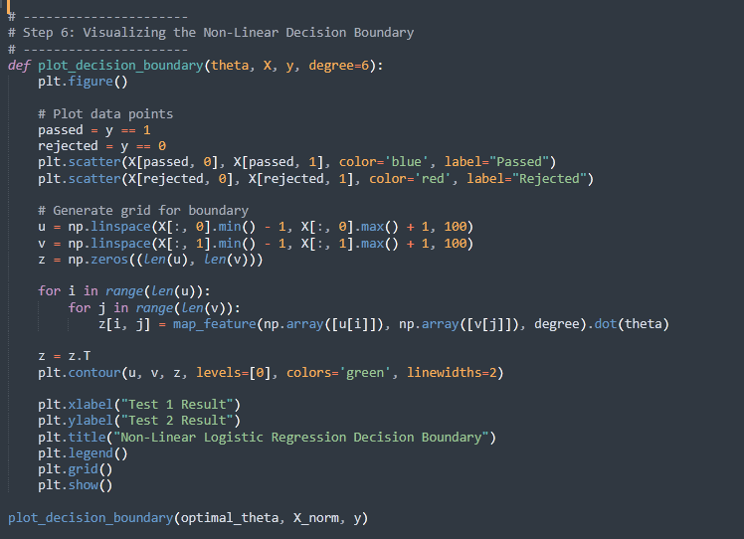
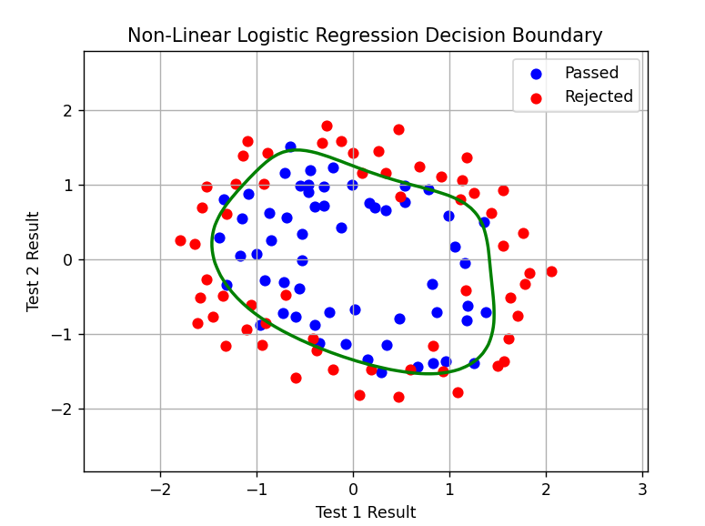

Next, the model's performance is evaluated by calculating the training accuracy, which is the percentage of correct predictions using predict(theta, X). The predicted values are compared with the actual values (y), and the mean of the correct predictions is computed. The result is multiplied by 100 to express the accuracy as a percentage. X_mapped contains the polynomial features of the input data, and optimal_theta contains the trained parameters of the model.
- Input:
  - theta: The optimized model parameters.
  - X: The feature matrix.
- Output: The predicted classes (0 or 1) for each example.

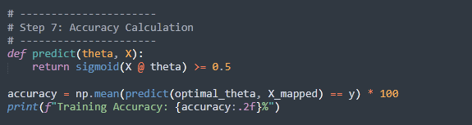
In the 8th step, the regularization parameter ambda is tested with values [0.1, 1, 10, 100]. For each value, the logistic regression model is trained again, and the accuracy is calculated. •For each regularization parameter, the model is optimized using the minimize function. The training accuracy is calculated after optimization.
Regularization helps prevent overfitting by penalizing large weights, but too much regularization can lead to underfitting. The goal is to find the best balance. The accuracies are plotted against the regularization parameter values to visualize the relationship between regularization strength and model performance. As seen from the graph, the accuracy fluctuates based on the strength of regularization. For lower values of λ, the model may overfit, resulting in high variance and poor generalization. As λ increases, the model becomes simpler and starts to underfit, leading to lower training accuracy. The optimal value of λ is the one that strikes a balance between overfitting and underfitting, where the model is sufficiently regularized to avoid large weights but still able to capture the underlying patterns in the data.
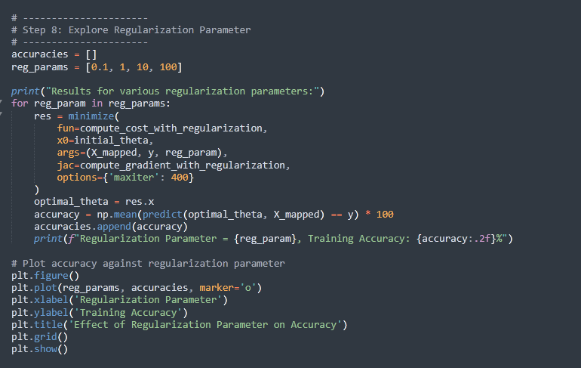

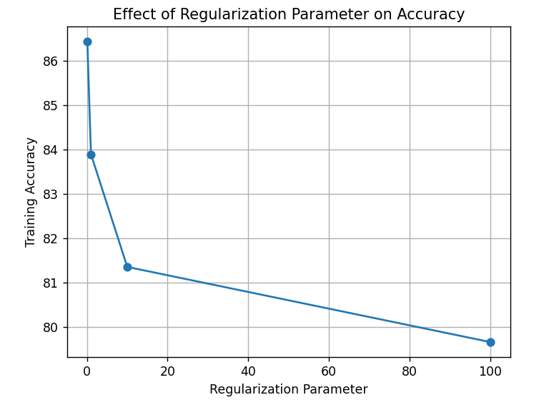
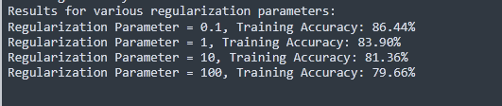
In the last step, the script focuses on displaying the results of the logistic regression model after training. It calculates the probability of admission for a given set of test scores, which allows for the prediction of whether a microchip is accepted or rejected based on these scores. This step includes both evaluating the final model's effectiveness through accuracy and understanding the impact of different learning rates on model performance.

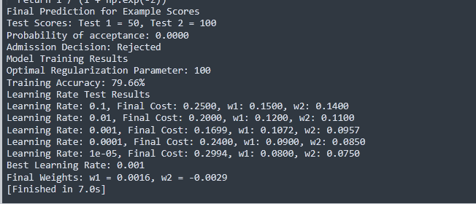

Degree 2:
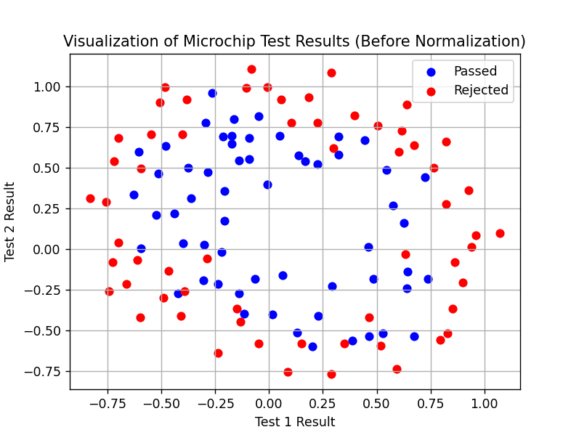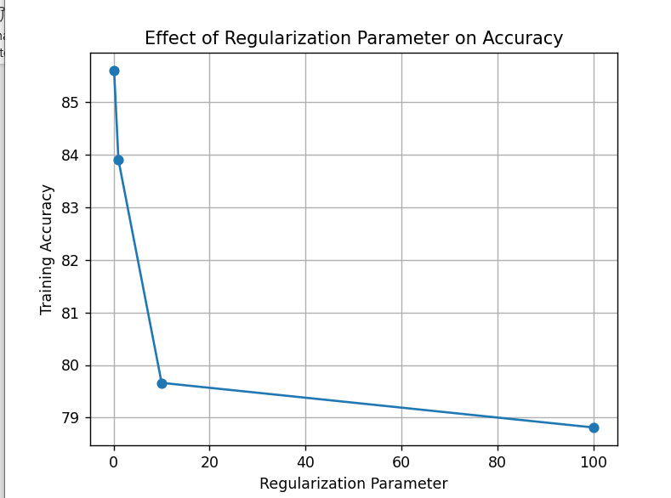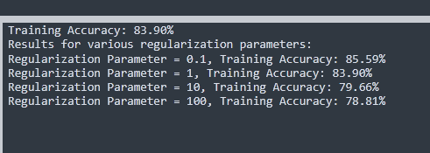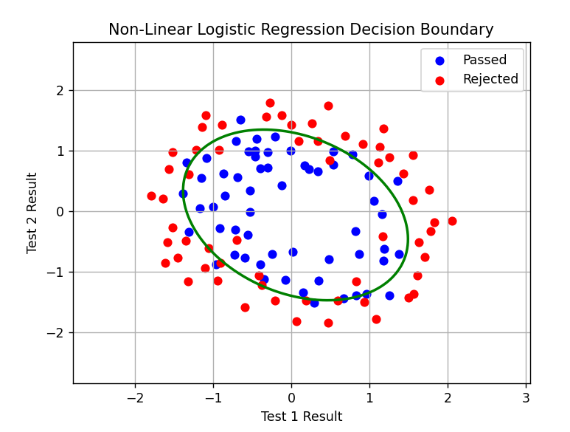

Degree 4:

